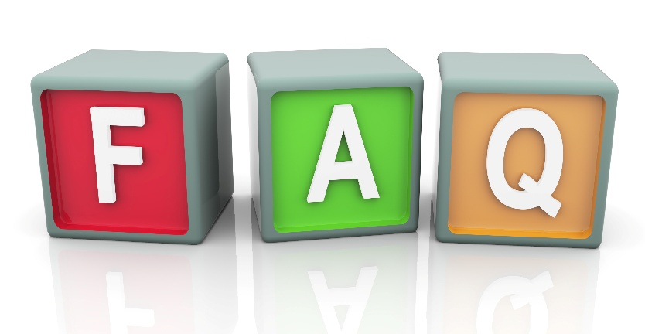
2026 Rate Change
South River EMC members will see a change in electric bills starting in March. This is due to the early retirement of facilities, changes to the generation mix, a rapid increase in demand, and rising costs in equipment.
Why is my rate changing?
It is South River EMC’s mission to deliver electricity at the lowest possible cost, and we work hard to achieve this goal. A recent cost-of-service study showed our current rates need to be adjusted to cover expenses and maintain financial stability. Factors include increased business costs, and higher demand.
What is the co-op doing to hold down costs?
South River EMC is committed to finding every savings opportunity possible. Additionally, the Cooperative is leveraging AI to streamline tasks and increase productivity. We are continually evaluating operations, reducing expenses where we can, and working to keep rates stable for as long as possible.

Where does the co-op get its power?
South River EMC purchases wholesale power generated from various sources, including nuclear, coal, hydro, natural gas, and renewable resources. Upgrading and modernizing generation facilities increase costs. Additionally, as required by North Carolina law, we are including renewable resources in our fuel portfolio – such as solar and wind facilities.

How does this change differ from the
Equalizer South River EMC has been using?
The Equalizer is a temporary measure used to recover unexpected increases, while a rate change is a long-term solution for permanent increases. A minimal Equalizer charge will continue through 2026 to recover shortfalls in January and February.
Why doesn’t the co-op cut its budget?
The co-op operates as leanly as possible without affecting service quality or safety. Budget cuts alone cannot offset the significant increase in delivery costs.
How much will my bill change?
The adjustment will impact all rate categories except Medium General Service.
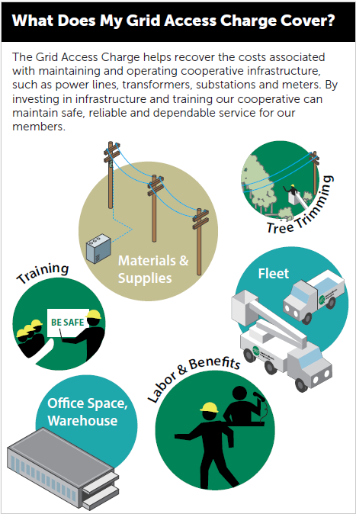
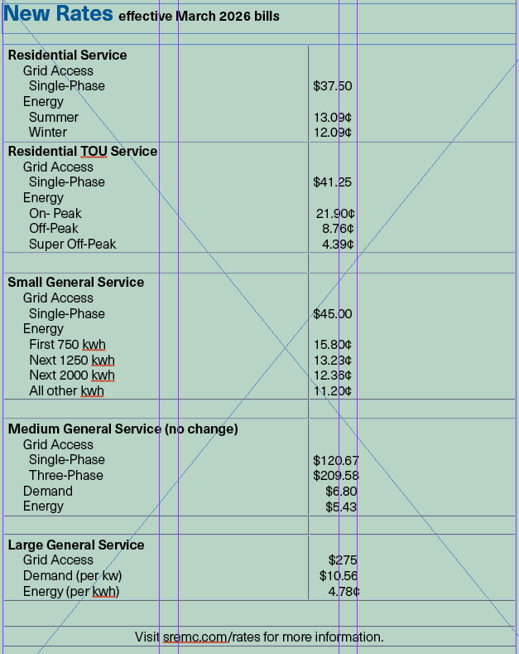

What can I do to help control my costs?
- Visit sremc.com and try out the energy calculators to see where you can reduce costs.
- Request a free home energy assessment.
- Consider converting to our time-of-use rate.
- Enroll in to receive energy-use alerts.
- Learn about South River EMC’s rebates and energy efficiency.
- Enroll your smart thermostat in Connect My Thermostat.
- Download the South River EMC app to manage your account, pay bills and report outages.

How can a time-of-use-rate help me save money?
Switch and Save, our time-of-use rate, encourages using energy during off-peak periods, potentially lowering your bill if you can shift energy use to off-peak times. For more information, sremc.com/tou.

