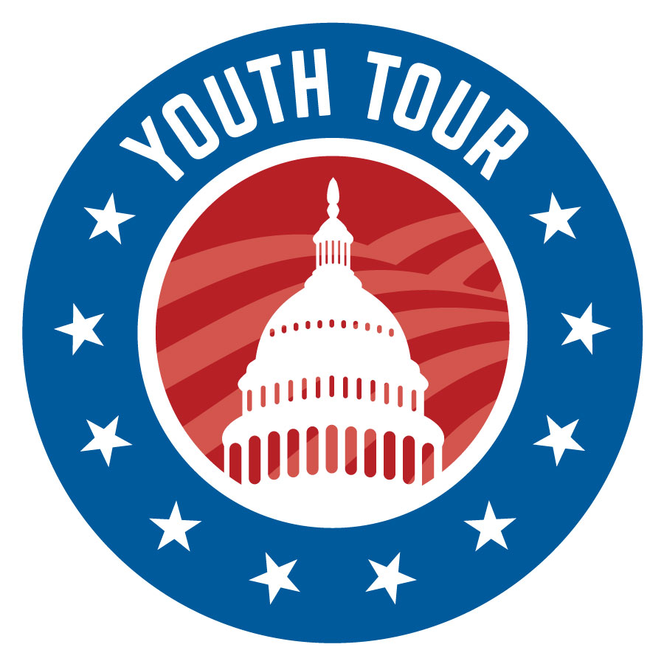

Rural Electric Youth Tour 2023

June 17-23

Name (first and last)

Name you go by Age

Address

City Zip

County

Cell number E-mail address

High school Current grade level

Parent’s phone numbers

Parents’ Names (first & last)

Do you have any allergies we should be aware of? If so, what? ☐ Yes ☐ No

Who Is Your Electric Company?

Any possible conflicts with the scheduled date for the Youth Tour? ☐ Yes ☐ No
If yes, please explain:

What academic and extra-curricular activities are you involved in? (Include additional sheets as necessary.)

Academic and extra-curricular honors received: (Include additional sheets as necessary.)

Please answer the following questions with at least 100 words each.
- What is a cooperative?

2. What is an important issue to you? Why?

3. Why is grassroots advocacy valid in today’s society?

4. Why do you feel you would be a good representative of South River EMC?

Return all information by the close of business January 17, 2023. All applicants will be asked to visit the cooperative for an informal interview. South River EMC will select three rising juniors or seniors to attend the 2023 Youth Tour. The final decision will be based on a combination of the application, essay answers and interview.

Those students who are selected and go on to attend the Electric Cooperative Youth Tour will be eligible for a $1,000 scholarship following their senior year of high school. The student will be required to provide the college’s name as well as their ID number issued by the school. Funds sent to the school will be used for tuition and books ONLY.

If you have any questions, feel free to contact Julie McLeod at 910-892-8071 ext. 2151, or by email at connections@sremc.com.

Applications can be e-mailed or submitted by mail to:

South River EMC
Attention: Youth Tour
PO Box 931
Dunn, NC 28335

