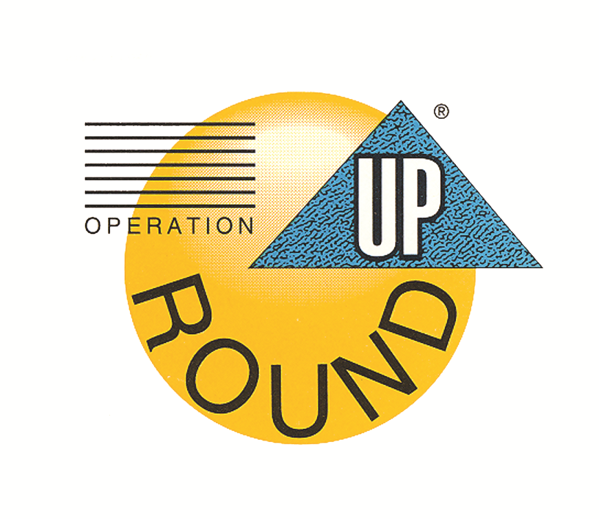

South River Electric
Membership Corporation

Application for Organization/Agency
This form must be used in the application process, do not use “see attached.” This application must be the top form in your packet.
Date Completed

- Name of Organization
- Address
City, State Zip
- Contact Person E-Mail
- Phone Number Alternate
- A copy of your organization’s financial statement from a previous year MUST be attached to this application.
- Is the organization requesting funding exempt from the payment of income tax? Yes ☐ No ☐
- What is the general purpose or goal of the organization?

- What will the requested funds be used for? How will the grant help your organization achieve its goal?

- Amount Requested (please attach an itemized budget) $
- How will this amount help your organization achieve its goal?

- Is the amount requesting the total amount needed? Yes ☐ No ☐
If no, what is the amount needed?
- What are your agency’s administrative costs?
- What communities are served by your agency/ organization?

- Approximately how many individuals or families do you serve?
Of the population you serve, approximately what percentage lives in South River EMC’s service area?

Does your facility receive electric service from South River EMC? Yes ☐ No ☐

- Please list other sources of funding for use of request as described on the first page. What has your
organization already done to raise the amount needed?

- How are your organization’s programs measured for effectiveness?

- CONTINGENCY PLAN: If we are unable to award a grant for some or your entire requested amount,
what alternatives do you have?

- How did your organization find out about Operation Round Up?

- If funded, how will your agency recognize Operation Round Up as donor?

- Will you accept partial funding? Yes No
If you indicated yes, what is the minimum amount you will accept?
The information contained in this statement is for the purpose of obtaining funding from the Community Assistance Corporation on behalf of the undersigned. The undersigned understands that the information provided herein is used in deciding grant funding, and the undersigned represents and warrants that the information provided is true and complete and that Community Assistance Corporation may consider this statement as continued to be true and correct until a written notice of a change is provided. The Community Assistance Corporation is authorized to make all inquiries they deem necessary to verify the accuracy of the statements made herein.

Name of Organization
Signature of Representative: Date
Completion of compete name serves as an electronic signature.

CHECKLIST:
☐ Please be sure your proposal letter contains all the information outlined in the
basic instructions and appropriate signatures (place behind application).
☐ Include copy of IRS letter indicating tax-exempt status and/or Federal ID Number.
☐ Include copy of organization’s mission statement.
☐ Include list of current board of directors.
☐ Include copy of most recent and previous year’s operational budget/ financial statement
(to include expenditures and income – NOT tax forms)
☐ Include appropriate bids, estimates, and bills directly relating to request.
☐ Include a detailed, itemized budget to support your request.
☐ If your organization is less than one year old, provide the most recent budget
statements.
☐ Send an electronic copy to codell@sremc.com. Additionally, submit 1 hard copy of the entire packet to South River EMC, PO Box 931, Dunn, NC 28335.

