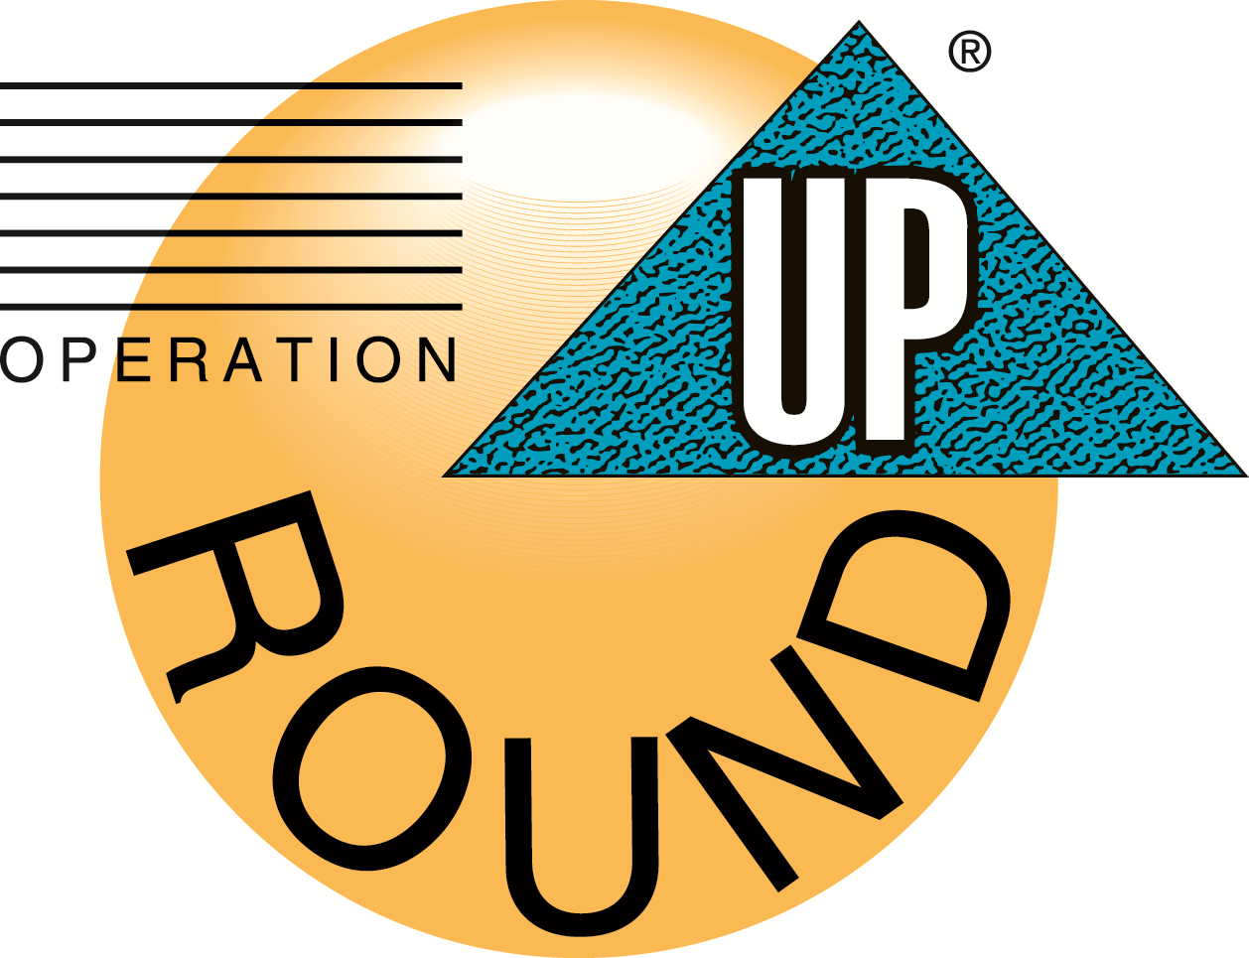

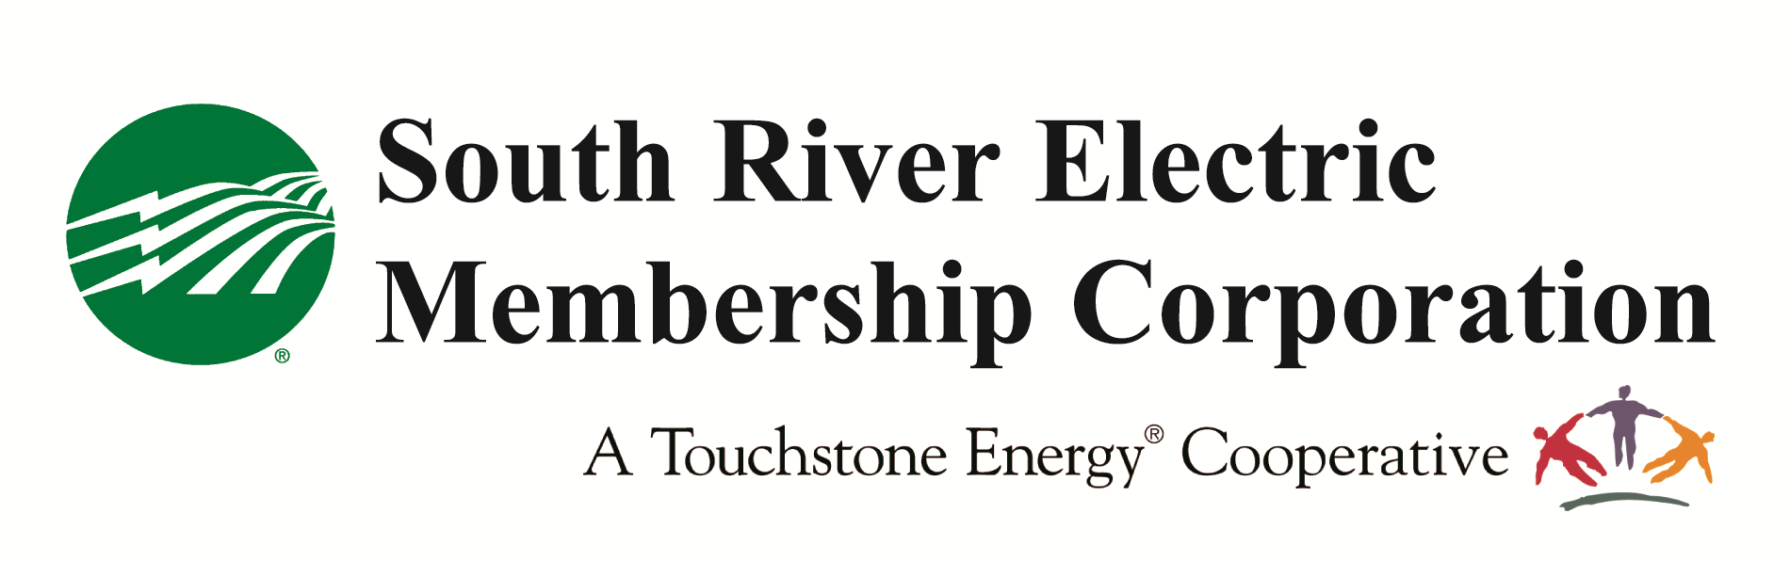
PO Box 931
Dunn, NC 28335
Phone: 910.230.2982
Fax: 910.230.2995
E-mail:codell@sremc.com

Educational Institution Application Procedures for Operation Round Up Grant Funding

NO HANDWRITTEN APPLICATIONS WILL BE ACCEPTED

South River Electric Membership Corporation administers Operation Round Up through the Community Assistance Corporation.

Educational Institutions:
- Educational institutions in Harnett, Cumberland, Sampson, Johnston and Bladen counties may be funded project between $2,500 and $10,000 annually.
- Funding goes only to educational institutions within areas that South River EMC serves.
- Funds cannot be used for operational expenses, to pay salaries or professional development.
- Projects must directly impact students.
- Funding cannot be given to local and state government agencies (with the exception of schools).
- Must attach appropriate bids, estimates, and bills directly relating to request.
- You must include a detailed, itemized budget for support your request.
- Tax forms will not be accepted in place of an operational budget.

Non-educational Organizations:
- DO NOT complete this application. Not-for-profit agencies must complete the application titled, “CAC Agency Application.”

General Information:
- Operation Round Up grants are awarded by the Community Assistance Corporation quarterly each calendar year in March, June, September and December.
- Notification of funding will be made by the last day of the funding month. For example, if you apply for the September distribution, your organization will be notified by the last day of September if it has or has not been awarded a grant.
- The appropriate application must be completed on the form provided. Packets submitted with re-created applications for “see attached” will be disqualified.
- Individual churches will not be considered for funding. Only religious-based programs that are collaborative community-based efforts among multiple churches or groups. Exceptions include church-sponsored programs that are run separately from the church and are self-sufficient (i.e. schools that are open to the community and are run by a separate board of directors/trustees).
- Application must be the first sheet of the packet.

Proposal Letter
The grant application must include a proposal letter along with the grant application and requested attachments. The proposal letter should be brief and concise, not to exceed two pages, single spaced, and should be signed by a designated representative.

The letter should include:
- An introductory description of the program and its impact on the community- be sure to include as much detail as possible the specific reason for your request (counties and areas included) and the number of people your project will affect. Place this behind the application when submitting the packet. Do not include these guidelines pages with packet.

- The amount of funding requested and the amount of the program budget.
- The need and specific population (including age, gender, and cultural background) which the program addresses.
- Specific objectives of the program and how accomplishment will be measured.
- Relationship of program to other services in the community which may be designed to meet the same or similar needs.
- Other sources of funding being approached (and when the funding would be received) and amounts already committed.

CHECKLIST:
Please be sure your proposal letter contains all the information outlined in the
basic instructions and appropriate signatures (place behind application).
Attach copy of IRS letter indicating tax-exempt status and/or Federal ID Number (public schools excluded)
Attach copy of organization’s mission statement.
Attach list of current board of directors (public schools excluded)
Attach copy of most recent and previous year’s operational budget/ financial statement (to
include expenditures and income – NOT tax forms) public schools excluded
Please include one copy of any publications that describe your organization. For example- brochures, pamphlets, organizational charts, etc. These should be attached to the original copy only.
Attach appropriate bids, estimates, and bills directly relating to request.
Attach a detailed, itemized budget to support your request.
If your organization is less than one year old, provide the most recent budget
statements.
Send one hard copy of the entire packet for consideration. Additionally, please send an electronic copy to codell@sremc.com.

If this is a new program, indicate how continued funding for the future will be secured.

For more information, contact Catherine O’Dell, vice president of member services and PR at codell@sremc.com, (910) 230-2982.

needs.

South River Electric
Membership Corporation


Educational Grant Application
Signature of the head of your organization is required (i.e. principal, president, etc.)

Date of Application Web Address

Legal Name of Organization

Complete Mailing Address

Name/Title/Address of Project Contact

Contact phone # E-mail

Amount of Request $
Project Name
County in which Project Services are provided
The information contained in this application is for the purpose of obtaining funding from the Community Assistance Corporation on behalf of the undersigned. Each undersigned represents and warrants that the information is true and complete and that the Community Assistance Corporation may consider this information is true and correct until a written notice of change is provided. The Community Assistance Corporation is authorized to make all inquires deemed necessary to verify the accuracy of the information.

Date
Authorized Signer’s Electronic Signature

Date
Name of Head of Institution (who has approved this project)

* Completion of compete name serves as an electronic signature.

