PO Box 931
Dunn, NC 28335
Phone: 910.230.2982
Fax: 910.230.2995
E-mail:codell@sremc.com

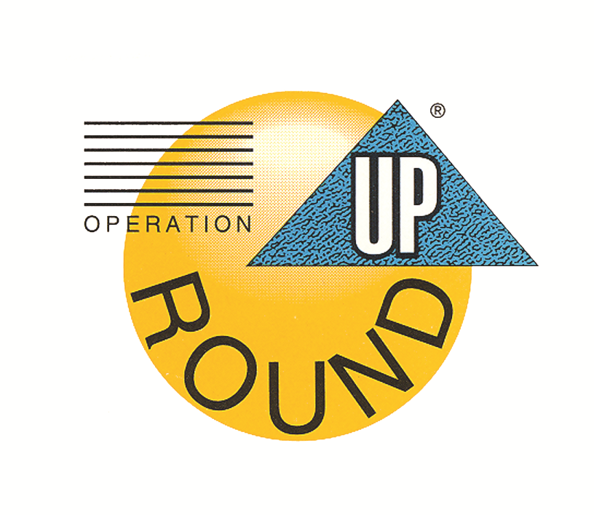
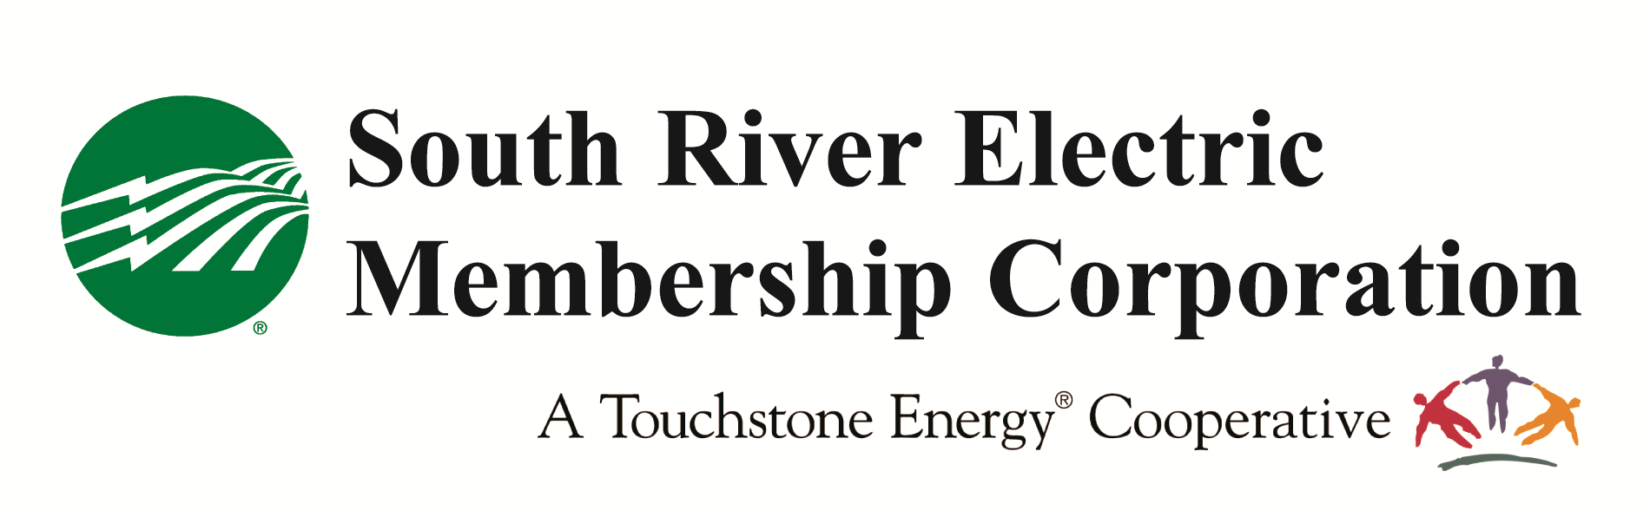

Application Procedures for Non-Profit Operation Round Up Grant Funding

NO HANDWRITTEN APPLICATIONS WILL BE ACCEPTED

South River Electric Membership Corporation administers Operation Round Up through the Community Assistance Corporation.

Non-Profit Agencies:
- Non-profit agencies in Harnett, Cumberland, Sampson, Johnston and Bladen counties may apply for up to $5,000 annually to implement programs or purchase needed equipment to facilitate a program, which will help in our local communities.
- Funding goes only to agencies within areas that South River EMC serves.
- Funds cannot be used to pay salaries or for general operational expenses. Funding must be targeting a specific program/project.
- Funding cannot be given to local and state government agencies.
- If an organization with a 501(c)3 has multiple programs, each program must operate separately and have separate boards of directors in order to be considered more than once in a 12-month period.
- Must attach appropriate bids, estimates, and bills directly relating to request.
- You must include a detailed itemized budget for support your request.
- Tax forms will not be accepted in place of an operational budget.
- Individual churches will not be considered for funding. Only religious-based programs that are collaborative community-based efforts among multiple churches or groups. Exceptions include church-sponsored programs that are run separately from the church and are self-sufficient (i.e. child care centers that are open to the community and are run by a separate board of directors/trustees).

Educational Institutions:
- DO NOT complete this application. Educational institutions must complete the application titled, “CAC School Application.”

General Information:
- Operation Round Up grants are awarded by the Community Assistance Corporation quarterly each calendar year in March, June, September and December.
- Notification of funding will be made by the last day of the funding month. For example, if you submit an application for the September distribution, your organization will be notified by the last day of September if it has or has not been awarded a grant.
- The appropriate application must be completed on the form provided. Packets submitted with re-created applications for “see attached” will be disqualified.
- Individual churches will not be considered for funding. Only religious-based programs that are collaborative community-based efforts among multiple churches or groups. Exceptions include church-sponsored programs that are run separately from the church and are self-sufficient (i.e. child care centers that are open to the community and are run by a separate board of directors/trustees).
- Application must be the first sheet of the packet.
- Completed application and all accompanying information should be submitted to codell@sremc.com. Please submit one hard copy of the packet.

Proposal Letter
The grant application must include a proposal letter along with the grant application and requested attachments. The proposal letter should be brief and concise, not to exceed two pages, single spaced, and should be signed by a designated representative.

The letter should include:
- An introductory description of the program and its impact on the community- be sure to include as much detail as possible the specific reason for your request (counties and areas included) and the number of people your project will affect. Place this behind the application when submitting the packet. Do not include these guidelines pages with packet.
- The amount of funding requested and the amount of the program/project budget.
- The need and specific population (including age, gender, and cultural background) which the program addresses.
- Specific objectives of the program/project and how accomplishment will be measured.
- Relationship of program/project to other services in the community, which may be designed to meet the same or similar needs.
- Other sources of funding pending (and when the funding will be received) and amounts already committed.

CHECKLIST:
 Please be sure your proposal letter contains all the information outlined in the
basic instructions and appropriate signatures (place behind application).
 Include copy of IRS letter indicating tax-exempt status and/or Federal ID Number.
 Include copy of organization’s mission statement.
 Include list of current board of directors.
 Include copy of most recent and previous year’s operational budget/ financial statement (to
include expenditures and income – NOT tax forms)
 Please include one copy of any publications that describe your organization.
For example- brochures, pamphlets, organizational charts, etc. These should
be attached to the original copy only.
 Include appropriate bids, estimates, and bills directly relating to request.
 Include a detailed, itemized budget to support your request.
 If your organization is less than one year old, provide the most recent budget
statements.
 Send an electronic copy to codell@sremc.com. Additionally, submit 1 hard copy of the entire packet to South River EMC, PO Box 931, Dunn, NC 28335.

If this is a new program, indicate how continued funding for the future will be secured.

For more information, contact Catherine O’Dell, vice president of member services and PR at codell@sremc.com, (910) 230-2982.

