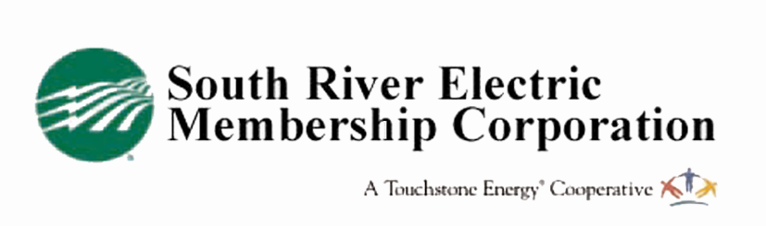
Mail to:
South River EMC
3rd Party Weatherization
PO Box 931
Dunn, NC 28335

3rd Party Weatherization Rebate Application
This form is for upgrades completed by a third party

Member Information

Name: ___________________ Account #: ______________________

Address: ___________________________________________________________

City: ____ NC Zip: ________________

Home Phone: ________________ Cell: ___________________________

Contractor Information:

Installation Contractor:Click here to enter text. Phone #____________________

Professional License:Click here to enter text. Date Work Completed:____________

Insulation Installed:  ☐ Attic  ☐Crawl Space | Existing Insulation (R value)  Attic:  Crawl: | New Insulation (R value)  Attic:  Crawl:
Ducts Sealed/Tested:  ☐Yes  ☐No | External Openings Sealed  ☐Yes  ☐No | Primary Heat Source  ☐Electric Furnace  ☐Heat Pump
Programmable Thermostat | Brand  Click here to enter text. | Model Number  Click here to enter text.

On-site verification required prior to issuing a rebate. Please allow 4-6 weeks to process this application and schedule an appointment. Rebate will be applied to the member’s electric service account as a credit.
I hereby agree that I am a South River EMC member and I have an active electric service account at the address indicated above. I also agree to hold South River EMC blameless from any problems arising from the performance of the work done or from any claims of savings, as these vary greatly depending on a number of factors.

_____________________________________________ ________________________
Member Signature Date

This rebate is for members who receive a weatherization package for their home performed by a third-party agency, such as Community Action, and includes air and duct sealing, insulation upgrade or replacement, HVAC tune up and the installation of a programmable thermostat. The home must be all-electric. Pay close attention to the difference in the rebate amounts for manufactured homes with heat pumps vs. those with electric furnaces and electric air conditioning.

Eligible Work:
- Duct sealing (Rebate may also be applied to duct replacement)
- Air sealing in all areas (see program details)
- Attic/Floor Insulation (upgrade) to code or greater* R38 for Harnett County/ R30 for Sampson, Johnston, Cumberland and Bladen counties.
- Installation of a programmable thermostat.
- Servicing or replacement of the HVAC system.

Rebate Amounts:
Full-House Weatherization for Single-Family Homes w/Heat Pumps - $200 bill credit
Full-House Weatherization for Single-Family Homes w/Electric Furnace - $200 bill credit
Full-House Weatherization for Manufactured Home w/Heat Pump -- $200 bill credit
Full-House Weatherization for Manufactured Home w/Electric Furnace -- $200 bill credit

Application Instructions:
- Complete and sign application
- Return application to South River EMC along with a copy of the bill of work describing all work completed by a contractor and dates of work completion—rebate will not be processed without these documents and an on-site inspection by South River EMC is required.

Eligibility:
- You must receive electric service from South River EMC in the home where the insulation and weatherization is conducted.
- Applicant must be home owner.
- The home must be at least five years old.
- Home must be all electric.
- The work must have been completed in the 90 days preceding the application for rebate.
- Work must be checked for compliance by an authorized South River EMC employee before a rebate is issued.

Restrictions:
- Rebates are subject to change without notice.
- All rebates are subject to approval and are contingent upon fund availability.

