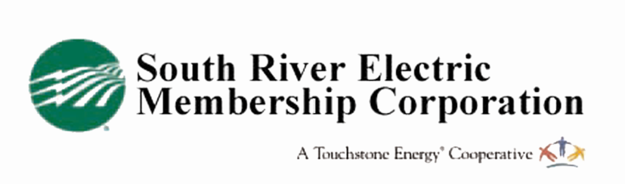
Mail to:
South River EMC
ES Appliance Rebate
PO Box 931
Dunn, NC 28335

ENERGY STAR Appliance Rebate Application

Member Information

NameAccount #

Address

City NC Zip

Home Phone Cell

Appliance Information (a separate application must be completed for each appliance)
Clothes Washer Clothes Dryer Refrigerator Dehumidified

Brand Model Number

Date of Purchase

I attest that all information submitted herein is true. This appliance was purchased by me and will be used in my home. I agree to submit a copy of my receipt of purchase along with the ENERGY STAR EnergyGuide to South River EMC as verification of sale and to retain for their records. I also understand that South River EMC will claim any energy savings realized through the purchase of this ENERGY STAR qualified appliance as part of their REPS mandate reporting*.

Member Signature Date

Authorized South River EMC Signature Date

Eligibility:
- You must receive electric service from South River EMC in your home where this appliance will be used.
- This program is intended for residential use only.
- Rebates will be issued only for electric clothes washers, clothes dryers, refrigerators and dehumidifiers that carry the ENERGY STAR label with the ENERGY STAR symbol.
- The appliance must have been newly purchased in the 90 days preceding the application for rebate.
- Receipt (or a copy) and EnergyGuide label must accompany application.
- Once an application is received by South River EMC and processed, a $10 bill credit will be applied to your account within 4-6 weeks.
- If an application is incomplete or does not include all required information, it will be denied and returned with an explanation.

Restrictions:
- Rebates are subject to change without notice.
- All rebates are subject to approval and are contingent upon fund availability.

*REPS mandate (Renewable Energy and energy efficiency Portfolio Standard) law, North Carolina General Statue 62-133.8 and North Carolina Utilities Commission Rule R8-67.

